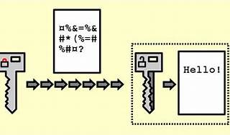

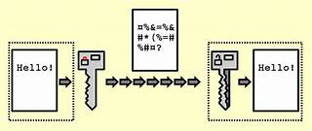

Explore

**Decryption** is the process of transforming data that has been rendered unreadable through encryption back to its unencrypted form. [In decryption, the system extracts and converts the garbled data and transforms it to texts and images that are easily understandable not only by the reader but also by the system1](https://www.techopedia.com/definition/1773/decryption)[2](https://softwarelab.org/blog/what-is-decryption/).

Here are **five free reference links** where you can learn more about programming, including encryption and decryption:

1. [**Programiz**](https://www.programiz.com/): Programiz offers beginner-friendly tutorials and examples for various programming languages like Python, SQL, R, HTML, JavaScript, Java, Rust, and more. You can learn to code, practice with online compilers, and explore interactive courses.
2. [**SoftwareLab**](https://softwarelab.org/blog/what-is-decryption/): SoftwareLab provides an explanation of decryption, emphasizing its importance for data protection and secure communication. Their article covers the basics and includes practical insights.
3. [**Encryption Consulting**](https://www.encryptionconsulting.com/education-center/what-is-decryption/): Encryption Consulting explains decryption as the reverse process of encryption. It involves converting encrypted data back into its original, human-readable form using cryptographic keys.
4. [**GeeksforGeeks**](https://www.geeksforgeeks.org/difference-between-encryption-and-decryption/): GeeksforGeeks discusses the difference between encryption and decryption. Encryption converts plaintext into ciphertext, while decryption reverses the process to obtain the original plaintext.
5. [**Coursera Tutorials**](https://www.coursera.org/tutorials): Coursera offers free online tutorials covering common programming issues. These tutorials include examples and interactive exercises to test your skills.

Happy learning! 🚀🔐👩‍💻